**Sprint planning 3**

AutoMate

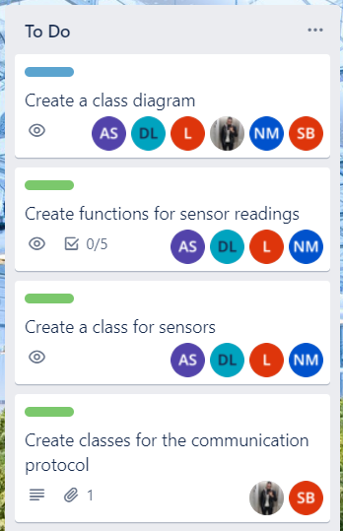

Above you see our Trello sprint board and there we include our planning. Our main goal for Sprint 2 was to have a stable communication prototype that we could enhance in future implementations. While making this plan we can say that we successfully achieved our goal for Sprint 2.

Our main goal for Sprint 3 is to have all sensors working and sending the variables to the Dashboard. This task refers to UC_001: “Monitor the plants health” in our Analysis document. In addition, we want to structure our code. We want to implement classes to our program. The plan is to first create a well worked out class diagram of the entire system and afterwards start coding creating the classes. We will split our team up into two groups. One team will work on the sensor class and the other will work on the communication classes.

As a side goal we will also have to update existing diagrams in our analysis document. After we have finished these tasks, we will have to create a presentation for the third sprint and make a new plan for Sprint 4.